Clinical Information Pack

Clinical Lecturer

|  |  |  |  |
| --- | --- | --- | --- |
| Post title: | **NIHR Clinical Lecturer in Primary Care** | | |
| Schools: | Primary Care, Population Sciences and Medical Education | | |
| Faculty: | Faculty of Medicine | | |
| Career Pathway: | Clinical | Level: | AMCS |
| Salary: | £77,769 | To | £100,810 |
| Associated NHS bodies | University Hospital Southampton NHS Foundation Trust (UHS) | | |
| Clinical category: | Balanced portfolio | | |
| Posts responsible to: | Head of School | | |
| Posts responsible for: | Research Staff and Postgraduate Research Students as appropriate | | |

**Particulars of Appointment**

The Faculty of Medicine wishes to appoint an NIHR Academic Clinical Lecturer, hosted by one of the following clinical specialties, Anaesthesia, Primary Care or Public Health.

The post is intended for an applicant within any of these two/three specialties, with the specialty of the final (single) post dependent on the successful applicant.

The applicant will have a higher research degree (or have submitted for such a degree) and appropriate research experience.

This pack sets out the details for the post as it would be linked to Primary Care, should this be the specialty of the successful applicant.

The post-holder will be pursuing their development of research and teaching within the School of Primary Care, Population Sciences and Medical Education in the Faculty of Medicine, University of Southampton.

In this post-doctoral role, the successful candidate will be in specialist clinical training at ST3 level or above and have substantial experience of the relevant research areas, a proven track record of high-quality original research publications, the ability to work well in a multidisciplinary, multi-professional team and hold a corresponding NTN or GP’s who have completed their vocational training, that have completed a higher research degree.

The post-holder will also have clinical commitments at University Hospital Southampton NHS Foundation Trust that will lead to the acquisition of clinical skills required for full registration within the specialty.

The post is subject to terms and conditions of service determined by the University of Southampton and in its honorary clinical capacity by the University Hospital Southampton Foundation Trust Board.

**The University of Southampton**

The University of Southampton is a leading research-intensive University, a member of the Russell Group and one of the top 100 universities worldwide. We deliver an excellent educational experience, world-leading research and we are known for successfully commercialising that research through enterprise.

This is an exciting time to join the University of Southampton. We have an aspirational University Strategy (see [www.southampton.ac.uk/strategy](http://www.southampton.ac.uk/strategy)), setting out our ambitions over the next five years. The strategy involves achieving a top 10 place in the UK for research, which we will achieve by investing in the highest quality staff and facilities. We are also transforming the education offer available to undergraduate and postgraduate students across the University, providing greater flexibility and modular courses, with a strong international focus.

**The Faculty of Medicine**

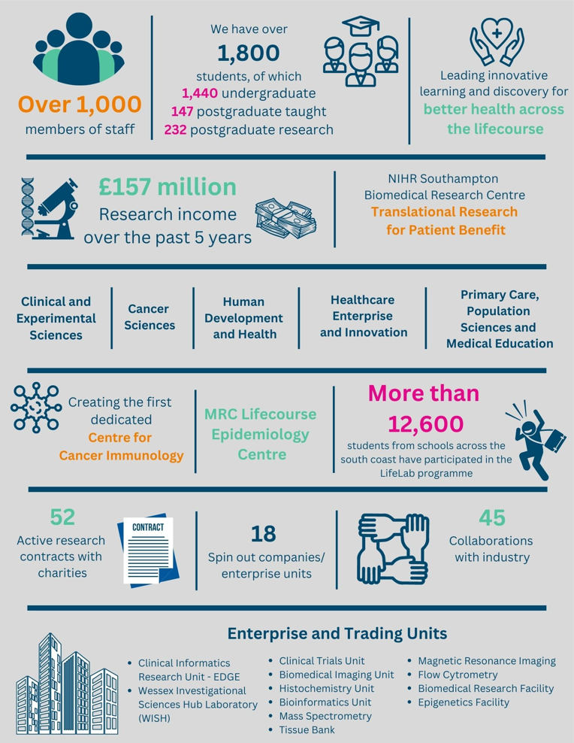

The creation of the Faculty of Medicine has enabled us to build upon strong foundations of basic research and clinical translation.  Working with colleagues across the University and in the local NHS we have strengthened our position as a renowned centre for translational research, leading innovative learning and discovery for better health across the life-course.  In this context, we are looking to appoint an outstanding senior academic to develop and lead a major programme of funded clinical research in the field of interstitial lung disease.

Key to the success of the Faculty of Medicine is the delivery of high-quality education for undergraduate and postgraduate students, building on our partnership in biomedical research with University Hospital Southampton NHS Foundation Trust and fostering new collaborations with the physical sciences, including chemistry, engineering and computing.

The Faculty celebrated its 40th anniversary in 2016. In 1971 FoM consisted of 40 students. FoM is now reputed for its excellence in research, innovative clinical teaching and is a vibrant pillar of the South of England community

**The Student Experience**

We offer a range of undergraduate programmes: the BM4 programme, a graduate-entry four-year programme which accepts 48 students per year; and the BM5 and BMedSc programme which accepts 200 students per year including approximately 30 students from a BM6 programme aimed at widening access to a medical career. Students also join the first two years for teaching in Southampton on the BM(EU) Programme, an affiliation with a German Medical school in Kassel. Biomedical/ Psychosocial Teaching in the first two years of the BM programmes is delivered in the South Block of Southampton General Hospital as well as on Highfield campus. Clinical teaching takes place at Southampton General Hospital and the adjoining Princess Anne Hospital, the Royal South Hants Hospital, and in NHS Trusts and General Practices throughout Hampshire, Dorset, West Sussex and Salisbury.

The BM5 programme has several distinctive features.   These include the integrated nature of teaching where the scientific disciplines are taught together in a clinical context using a systems-based approach and the BMedSc programme, a four-month supervised research project undertaken in Year 3. There is also the opportunity, for selected students, to undertake an integrated, intercalated Masters in Medical Science (MMedSc).  The BM4 programme also has several key features.  These include clinical topics in the first two years where students meet on a regular basis in Graduate Groups and learning with BM5 students in the third and fourth years on all clinical attachments.  All students take the same final examinations.  All programmes have substantial clinical experience in the first two years, student selected components, dispersed final year attachments, work shadowing prior to commencing a Foundation post and inter-professional learning.

In addition to the undergraduate BM programmes the School provides four Masters Degree programmes in Public Health, Allergy, Genomics and Diabetes plus an MRres.

**Research and Enterprise**

The Faculty of Medicine has a clear research strategy to investigate the biomedical basis of common human diseases and to translate this into clinical practice. All research undertaken within the Faculty has clear evidence of international excellence and is delivered through appropriate Faculty Schools.

The Faculty of Medicine Enterprise Strategy is fully aligned to the University Enterprise Strategy to provide a step change to its enterprise and innovation culture, delivering global outreach, community engagement, innovative healthcare and policy. We work with all stakeholders from industry and pharma to health providers and the community.

**Equality, Diversity and Inclusivity**

We are committed to positively advancing equality of opportunity. We participate in a number of equality initiatives which celebrate good employment practice for the advancement of diversity, equality and inclusivity. These include the Stonewall Workplace Equality Index, the Race Equality Charter and Athena Swan, (for which we are currently silver award holders). We also have a number of staff equality committees who champion the advancement of equalities for diverse groups.



**Southampton Behaviours**

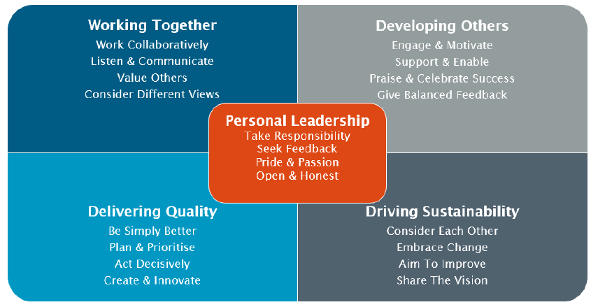

**School Information**

**Primary Care, Population Sciences and Medical Education** (PPM) is one of the five Schools in the Faculty of Medicine (Head Professor Nick Francis). PPM has a single management structure with regular Executive meetings and termly all-staff awaydays, to consider policy, strategy, and research oversight. The **Primary Care Research Centre (PCRC)** is the largest group in PPM, which also contains a Public Health group, Medical Education group, and NIHR Research Support Service (**RSS**) South Central.

The School encompasses a wide range of academic disciplines for applied health research: clinical primary care and public health; epidemiology; medical statistics, qualitative methods, health economics, and health psychology.  We have strong research collaborations with relevant clinical disciplines in the Faculty of Medicine and methodologists and clinicians in other Faculties, (notably in Psychology, Infectious Disease, Respiratory, Medical Sociology, Statistics, Nursing and Health Geography).

**Primary Care Research Centre (PCRC)**

We are one of only nine member departments nationally of the [NIHR School for Primary Care Research (NIHR SPCR)](https://www.spcr.nihr.ac.uk/). We provide an energetic, productive and nurturing research environment. We aim to produce world-leading research, informed by patient and public involvement (PPIE), workingwith health professionals and policy makers and developing research students, to strengthen primary care practice and improve patient outcomes.

PCRC has increased in size, productivity, and influence with several new senior appointments being made in 2023/24. We have 9 professors, 5 associate professors, 3 clinical lecturers, 3 clinical research fellows, 20 post-docs, 8 doctoral students, and 32 research staff.

Our annual research income rose from £2.8M in 2013-14 to £4.8M in 2019-20.

PCRC involves public contributors in governance and in all research projects and has an active programme of community partnership. The PPIE steering group includes 4 core public contributors, 2 PPIE officers, senior academics, research manager and research administrator.

Developed to align with national priorities, and designed to facilitate cross-fertilisation and synergy, our five major, overlapping, **themes of research** are:

* **Supporting self-management** addressing increasing needs for self-management of infections, including new viruses, non-communicable long-term conditions, and disability, for an ageing population facing increasing multimorbidity, frailty, and polypharmacy. It builds on our close links with Psychology and international reputation for developing and evaluating digital interventions.
* **Improving use of medicines** including database and observational studies describing medicine use and associated outcomes, qualitative studies of patient and prescriber perspectives, and trials evaluating effectiveness of medicines and optimal use (including deprescribing where appropriate).
* **Healthcare communication** seeking to improve patient outcomes by optimising healthcare interactions, including developing tools to enhance empathy and positive messages, evaluating agenda-setting within consultations, and detailed conversation analysis of video- and audio-recorded consultations to improve communication.
* **Diagnosis and prognosis** including prospective observational studies, routine data studies, qualitative studies, diagnostic studies and randomised trials to improve the management of common conditions in primary care. Ongoing studies focus on diagnosis and prognosis of COVID-19, sore throat, urinary tract infection (UTI), asthma and chronic obstructive pulmonary disease (COPD), mental health problems, atrial fibrillation (AF), and cancer.
* **Data Science:** Uses large volumes of complex, heterogenous, multi-dimensional and often unstructured dataset from different sources with the aim of understanding patterns, trends, and associations of diseases to inform preventive action. We use traditional statistical methods alongside artificial intelligence algorithms to draw insights on real-world problems.

Cross cutting these themes are our main **clinical areas** of:

* **Infections and antibiotic stewardship**
* **Long-term conditions** (respiratory; mental health; skin; gastrointestinal; musculoskeletal; cancer; cardiovascular etc.)
* **Healthy ageing**
* **Integrative health care**



Our annual research income rose from £2.8M in 2013-14 to £4.8M in 2019-20. Total PPM income over the seven year period was £24.3M (compared to £9.0M for REF2014 over five years), including £21.4M won in open competition from the NIHR and £1.1M from UK research councils. Of 500 grant applications, 187 (37.4%) were successful.

Recent major grants led by CIs at Southampton include:

**10** **NIHR** **PGfAR** **programmes:**

* DIPSS on asthma and hypertension (total *including all partners* £2M);
* CLASP on cancer survivorship (total £2M);
* PRIME on acute respiratory tract infections (RTIs) (£2M);
* ECO on eczema self-management (£2.7M);
* ACO on acne self-management (£1.9m)
* REDUCE on antidepressant reduction (£2.4M);
* RECON on cognitive decline (£2.3M);
* STREAM on malnutrition (£2.2M);
* RECUR on recurrent RTIs (£2M).
* AIM on multimorbidity using big data (£2M)

**7 NIHR HTA** **trials:**

* COAT for cellulitis (£1.48m)
* ACTIB for irritable bowel syndrome (IBS) (£700K);
* SAFA on spironolactone for acne (£1.7M);
* PROMDEP for assessing depression (£1.6M);
* ATLANTIS on amitriptyline for IBS (£1.7M);
* SupportBack2 on back pain (£1.2M).
* AFLOAT for lower respiratory tract infections in older adults (**£1.7M**)

Also

NIHR HSDR - Phased In Antimicrobial Stewardship (£1M)

SPCR - TIP – communication skills training (£1M)

In addition we co-lead the £22M PANORAMIC antiviral research platform, and DEFINE FeNO guided asthma care programme, both with Oxford.

There is active use of large databases including CPRD, SAIL, Q-Research, Care and Health Information Exchange Analytics (CHIA) and there is strong methodological input in medical statistics, health economics and qualitative methods.

**Research Students**



Currently we have 7 PPM doctoral students registered in the Faculty, all jointly supervised by two or more academics. In addition, we have 8 students jointly supervised, but registered with other groups (mainly Health Psychology and Health Sciences), arising from our extensive collaborations.

We support and attract research students through:

* Membership of the NIHR School for Primary Care Research, giving access to annually awarded non-clinical PhD studentships and Primary care focussed research training;
* Being one of 10 departments nationally to be awarded Wellcome-funded Clinical PhD fellowships for GP doctorates;
* The Associate Dean for Research’s programme of workshops and individual support for applications for external fellowships including mock interviews;

Our doctoral students undertake individualised learning needs analyses within a month of enrolment and agree tailored training and an annual formal assessment with an adviser outside the supervisory team. PPM provides funding for training and conference attendance and holds a very successful annual PhD presentation conference.

Students receive training and support in PPI, and access to Faculty generic research methods training and pastoral support through programmes run by the Graduate School and Southampton Clinical Academic Training Scheme.

Our doctoral students undertake individualised learning needs analyses within a month of enrolment, and agree tailored training and an annual formal assessment with an adviser outside the supervisory team. PPM provides funding for training and conference attendance and holds a very successful annual PhD presentation conference.

**Primary Care Research Centre – Senior Staff**

Head of PPM: Professor Nick Francis

Head Primary Care: Professor Hazel Everitt

Professor Helen Atherton

Professor Tony Kendrick

Professor Geraldine Leydon

Professor Paul Little

Professor Tracey Sach

Professor Miriam Santer

Associate Professor: Dr Hajira Dhamba-Miller

Associate Professor Adam Geraghty

Associate Professor Kinda Ibrahim

Associate Professor Nazrul Islam

Associate Professor: Leanne Morrison

Associate Professor Ingrid Muller

Associate Professor Kay Wang

Clinical Lecturer: Dr Mark Lown

Clinical Lecturer: Dr Merlin Willcox

NIHR Clinical Lecturer: Dr Sara McKelvie

Job Description and Person Specification

|  |
| --- |
| Job purpose |
| To undertake research in accordance with specific research projects under supervision as above (0.5fte); and to undertake clinical duties as a Specialist Registrar (0.5fte) |

|  |  |  |
| --- | --- | --- |
| Key Research accountabilities | | % Time |
|  | |  | | --- | | To develop and carry out an area of personal research. | | To disseminate findings in peer-reviewed journals, present results at conferences or exhibit work at appropriate events. | | To contribute to the writing of bids for research funding. | | Carry out administrative tasks associated with specified research funding, for example risk assessment of research activities, organisation of project meetings and documentation. Implementation of procedures required to ensure accurate and timely formal reporting and financial control. | | 40% |

|  |  |  |
| --- | --- | --- |
|  | Key Education accountabilities |  |
|  | |  | | --- | | As a member of a teaching team within an established programme of study, support the teaching objectives of the School/Department by delivering teaching to students at undergraduate and/or postgraduate level, through allocated lectures, tutorials, practicals and seminars. | | Directly supervise students, providing advice on study skills and helping with learning problems. Identify the learning needs of students and define learning objectives. Set and mark coursework and exams, providing constructive feedback to students. |  |  | | --- | | Develop own teaching materials, methods and approaches, with guidance. Obtain and analyse feedback on own teaching design and delivery to facilitate this. | | Continually update own knowledge and understanding of subject area, incorporating knowledge of advances into own teaching contributions. | | 5% |

|  |  |  |
| --- | --- | --- |
|  | Key Management, Leadership and Engagement accountabilities |  |
|  | Contribute to the efficient management and administration of the School/Department by performing personal administrative duties as allocated by the Head, e.g. library representative, year tutor, exchange-programme coordinator, etc. | 5% |

|  |  |
| --- | --- |
| Key Clinical accountabilities | % Time |
| GP Clinical Lecturers are responsible for arranging their own clinical work in a practice of their choosing. | 50% |

| Internal and External Relationships |
| --- |
| May have additional reporting and liaison responsibilities to external funding bodies or sponsors.  Collaborators/colleagues in other work areas and institutions. |

| Staff Benefits |
| --- |
| Working at the University of Southampton gives you access to a wide range of benefits in addition to our competitive rates of pay. Our core benefits include pension scheme membership; a generous annual leave allowance (supplemented by University closure days and public holidays) and excellent family leave arrangements (including maternity, paternity, adoption and parental leave).   * Faculty Mentoring Scheme; * Ability to remain in NHS pension scheme, subject to qualifying criteria; * Discounted Sport and Wellbeing membership; * Access to private dental and/or healthcare insurance; * Cycle to work scheme * Tax-Free childcare |

**Person Specification**

|  |  |  |  |
| --- | --- | --- | --- |
| Criteria | Essential | Desirable | How to be assessed |
| Qualifications, knowledge and experience | Medical degree  GMC registration  Evidence of completion of General Practice training  or  currently in General Practice training at ST3 or above and appointable to NTN or hold NTN already  Evidence of commitment to a clinical academic career  Evidence of ability to undertake statistical analysis  Competence in use of statistical analysis software  PhD/MD (or equivalent) in a research area relevant to the post. The applicant must have submitted their PhD or MD thesis at the time of application, and the higher research degree must be awarded before commencing post.  Experience of undergraduate/postgraduate medical teaching  Experience of undergraduate/postgraduate medical teachingCompetence in use of statistical analysis software  Completed PhD or currently registered for PhD with thesis submitted  Experience of undergraduate/postgraduate medical teaching | Experience in conducting a systematic review  Experience in a clinical trial in the community  Experience in developing a complex intervention, e.g digital interventions  Experience in qualitative research  MRCGP | CV/interview |
| Planning and organising | Ability to organise own research activities to deadlines and standards |  | CV/Interview |
| Problem solving and initiative | Ability to develop understanding of complex problems and apply in-depth knowledge to address them |  | CV/interview |
| Management and teamwork | Work effectively in a team, understanding strengths and weaknesses of others | Ability to work in a multi-professional team | CV/interview |
| Communicating and influencing | Communicating new and complex information effectively, both verbally and in writing, engaging the interest and enthusiasm of the target audience  Ability to present research results at group meetings and conferences  Track record of original publications in leading peer-reviewed journals  Work proactively with colleagues in other work areas/institutions, contributing specialist knowledge to achieve outcomes | National/ international research award(s) | CV/interview |
| Other skills and behaviours | Positive attitude to colleagues and students. |  | CV/interview |
| Special requirements | Able to attend national and international conferences to present research results | Experience of presenting at national and international conferences | CV/interview |

**JOB HAZARD ANALYSIS**

**Is this an office-based post?**

|  |  |
| --- | --- |
| Yes | If this post is an office-based job with routine office hazards (eg: use of VDU), no further information needs to be supplied. Do not complete the section below. |
| No | If this post is not office-based or has some hazards other than routine office (eg: more than use of VDU) please complete the analysis below.  Hiring managers are asked to complete this section as accurately as possible to ensure the safety of the post-holder. |

## - HR will send a full PEHQ to all applicants for this position. Please note, if full health clearance is required for a role, this will apply to all individuals, including existing members of staff.

|  |  |  |  |
| --- | --- | --- | --- |
| **ENVIRONMENTAL EXPOSURES** | **Occasionally**  (<30% of time) | **Frequently**  (30-60% of time) | **Constantly**  (> 60% of time) |
| Outside work |  |  |  |
| Extremes of temperature (eg: fridge/ furnace) |  |  |  |
| ## Potential for exposure to body fluids | ✓ |  |  |
| ## Noise (greater than 80 dba - 8 hrs twa) |  |  |  |
| ## Exposure to hazardous substances (eg: solvents, liquids, dust, fumes, biohazards). Specify below: |  |  |  |
| Frequent hand washing |  |  |  |
| Ionising radiation |  |  |  |
| **EQUIPMENT/TOOLS/MACHINES USED** | | | |
| ## Food handling |  |  |  |
| ## Driving university vehicles(eg: car/van/LGV/PCV) |  |  |  |
| ## Use of latex gloves (prohibited unless specific clinical necessity) | ✓ |  |  |
| ## Vibrating tools (eg: strimmers, hammer drill, lawnmowers) |  |  |  |
| **PHYSICAL ABILITIES** | | | |
| Load manual handling |  |  |  |
| Repetitive crouching/kneeling/stooping |  |  |  |
| Repetitive pulling/pushing |  |  |  |
| Repetitive lifting |  |  |  |
| Standing for prolonged periods |  |  |  |
| Repetitive climbing (ie: steps, stools, ladders, stairs) |  |  |  |
| Fine motor grips (eg: pipetting) |  |  |  |
| Gross motor grips |  |  |  |
| Repetitive reaching below shoulder height |  |  |  |
| Repetitive reaching at shoulder height |  |  |  |
| Repetitive reaching above shoulder height |  |  |  |
| **PSYCHOSOCIAL ISSUES** | | | |
| Face to face contact with public | ✓ |  |  |
| Lone working | ✓ |  |  |
| ## Shift work/night work/on call duties |  |  |  |